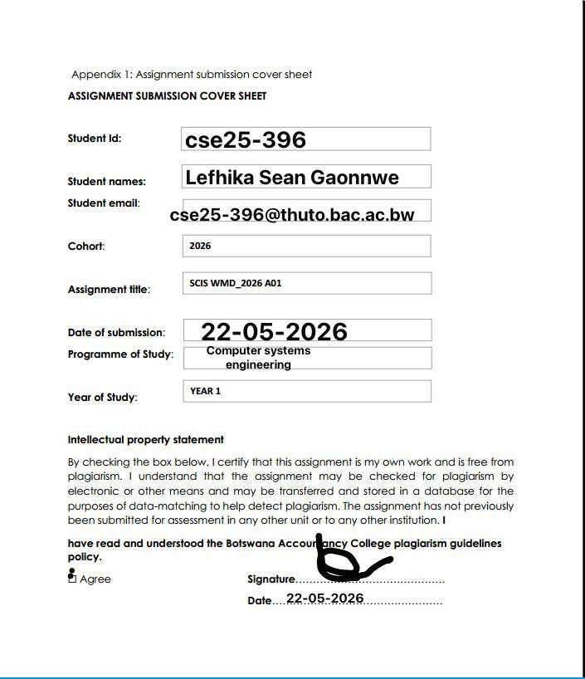

MEDI-CRAFT

WEBSITE SPECIFICATION DOCUMENT

PROJECT OVERVIEW
Website name : MediCraft
MediCraft is a medical equipment supplier and service provider that specializes in the supply, instalment and maintenance of medical equipment and supplies .The MediCraft website allows for a wide scale reach to all customers nationwide , allowing for purchases to be made within the website.
TARGET AUDIENCE
MediCraft aims to be interacted with by wide range of medical professionals for industrial use and individuals who require products and services for personal use.
Main targets being:-
-Hospitals: Supplying them with all major equipment e.g diagnostic tools (X-ray, MRI, CT scanners, ultrasound), life-support systems (ventilators, anesthesia machines, defibrillators), and monitoring devices (ECG, patient vitals monitors).
-Clinics: Diagnostic tools (stethoscopes, BP monitors, thermometers, ECG machines, and ultrasound), treatment devices (nebulizers, defibulators, surgical instruments, suction machines) and essential exam furniture
-Laboratories: Centrifuges for separation, automated analyzers (hematology, chemistry, immunoassay), microscopes, and incubators for cultures
-Any local businesses or individuals that may require any medical equipment or supplies

MEDI-CRAFTS VISION, MISSION AND GOAL
- Vision: To create a future where no Motswana waits for a life-critical result, realized through a self-reliant diagnostic network that sets the global benchmark for reliability and citizen-led engineering.
- Mission: MediCraft: Precision Technology. Local Expertise. National Health.
- Goal: Improve Batswana’s understanding how to handle, operate and function medical equipment ,as well as building a stronger reliance on the equipment in all areas (urban and rural)

WEBSITE OBJECTIVES
- Provide company information: Give the user a better understanding of what the business entails and does to clear or reduce any type of existing confusion .
- Sell products and services: Allow the user purchase products from the business as well as booking service maintenances for those products or any other relating products
- Collect customer feedback: After the user has interacted and used the website they should be able to give their thoughts on it and what should be improved to better future use for them and other users.

WEBSITE STRUCTURE/SITEMAP
- Home page: The first page the user interacts with before doing anything. It gives them an introduction to the website offering specials the business has to offer as well link that guide to the action they are trying to perform

- Purchases page: This is where the user will place their order as well as booking the service of their choice . The available products will be displayed here allowing the user to pick what they want to buy.

- Checkout page: This is where the all items the products selected on the purchases page are displayed. It shows the amount of the item ,the total price of all products choosen and allows you to make the payment here and send your order to the business.

- Purchase history page: This is where users will view past purchases , these being the products or service ,number of items bought as well as the price of each item and the total amount paid for them.

- Contact page: The contact information (email addresses ,phone numbers) of the business are found here allowing the user to have a way to reach and communicate with the business .The contact page also contains the physical address of the business.

- About us page: Contains more detailed information about the business for any users that would to gain a more detailed understanding of it.

- Feedback page: This where the user can share their thoughts on the website as well as suggesting any issues they faced and fixes or improvements to those issues .This helps in the maintenance of the website too.

SITEMAP: The home page links all the pages together as it’s the first page that is displayed when the website is visited. From the home page all the other pages can be accessed .

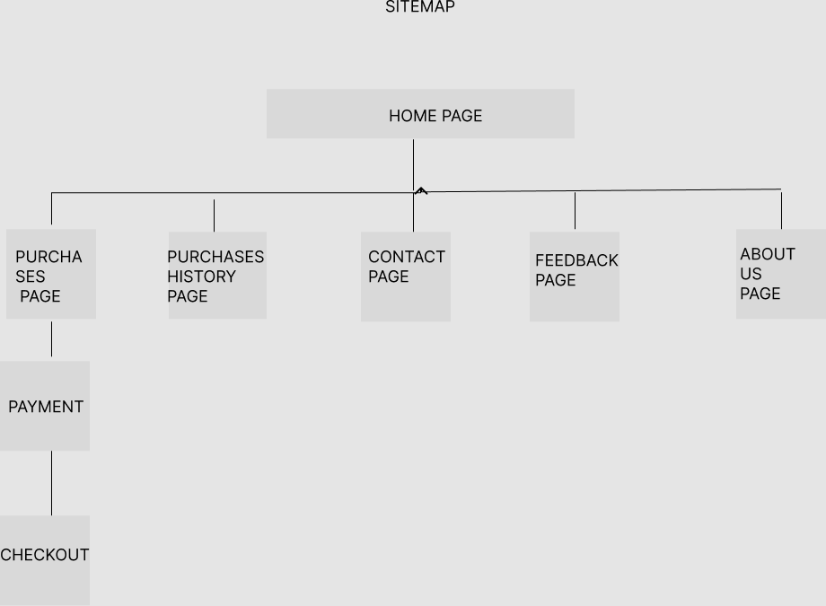

WEBSITE PAGE WIREFRAMES
Here I will show the low level wireframes of each webpage then the high level wireframe of the entire website.

Home Page
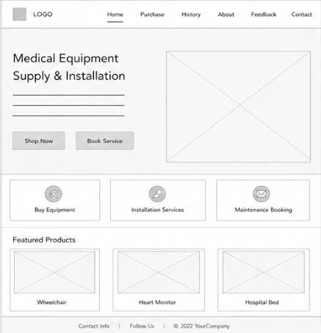

This is opening page of the website that shows what is being offered to the user and the following action they can take. It has navigation that can the user to the purchases page primarily and other pages as well.

Purchases Page

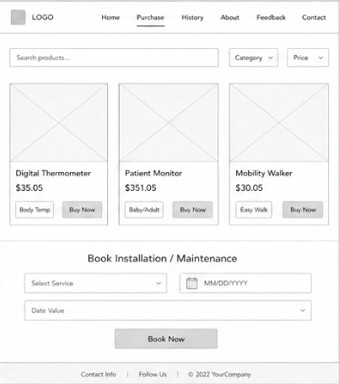

This is the page that allows the user to buy equipment or book services such as installations or maintenance.

Checkout page
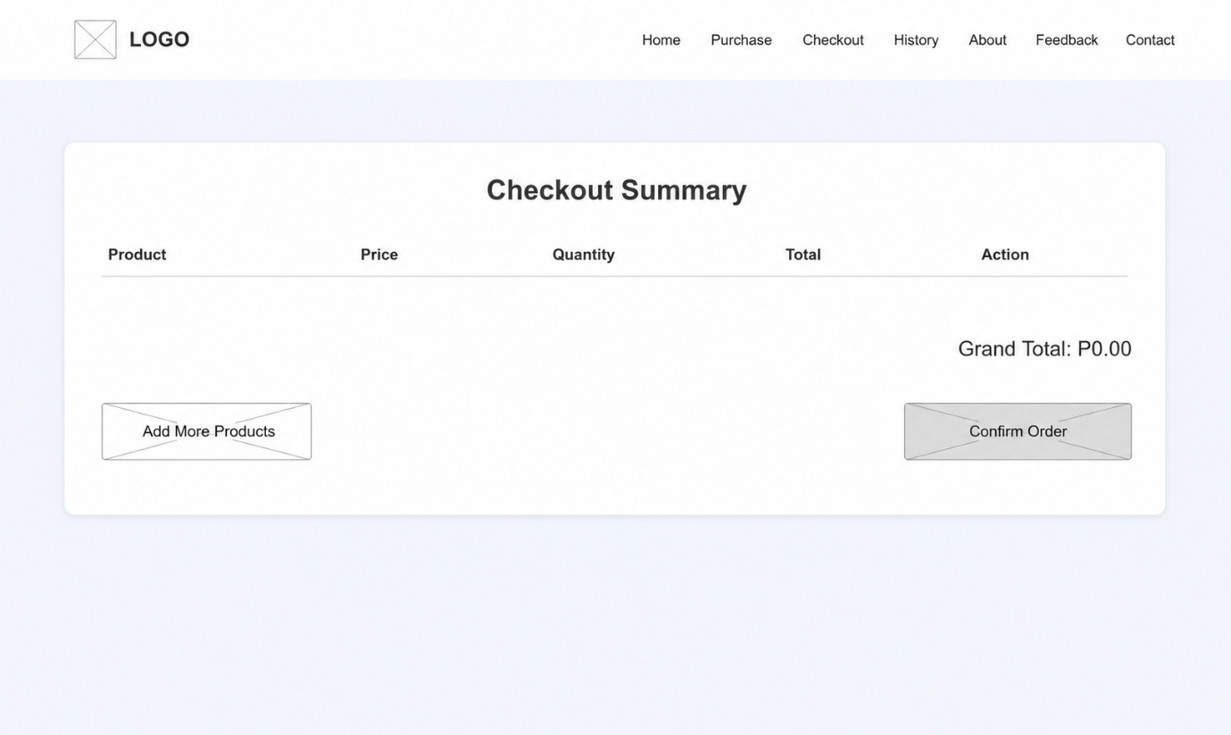

This page allows confirmation of purchases of selected products from the purchases page.

Purchase History Page
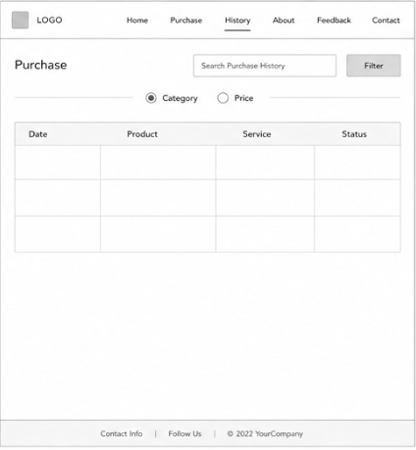
This page allows for the user to view past purchases and bookings as well the progress of the order in terms if the equipment or booking have been provided yet or if they are still pending or unavailable. The prices paid are also displayed on this page .

About Page
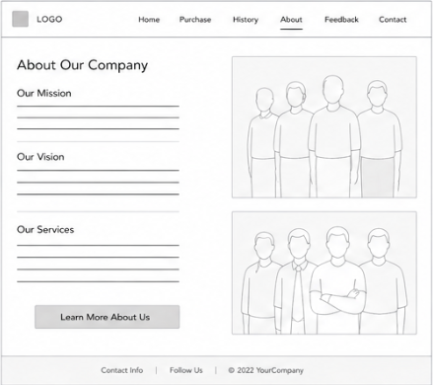

This page provides the user with more in depth information of the business and what it has to offer users .It is also here clear any type of confusion the user may have about the business.

Contact Page
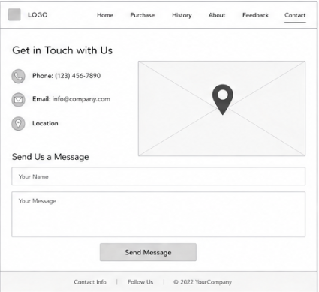

This page gives the user ways to get in touch with the business if they need to make any inquires about anything or if they want make specific orders . The physical location is also given here as well.

Feedback Page
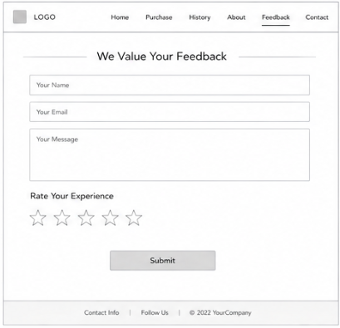
The feedback allows for the user to rate the experience they had interacting with the website and the business. This helps with resolving any issues they may have faced during the time they spent with website and within the business.

Now here we have the high level wireframes:-
Home page

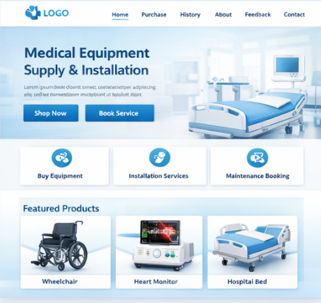

Purchases page
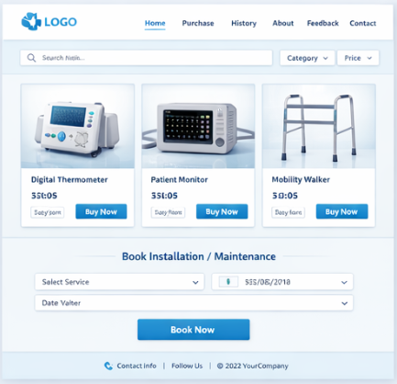
Checkout page
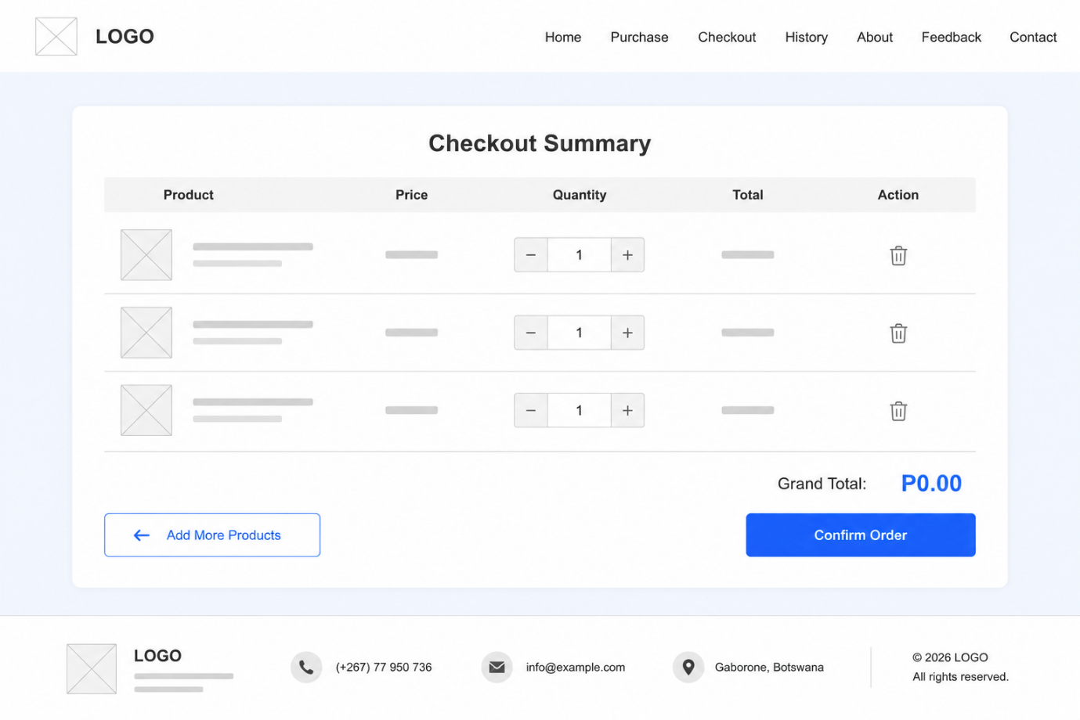
Purchases history page
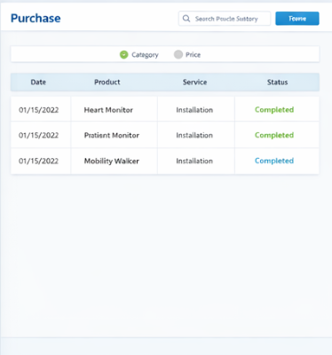

About page
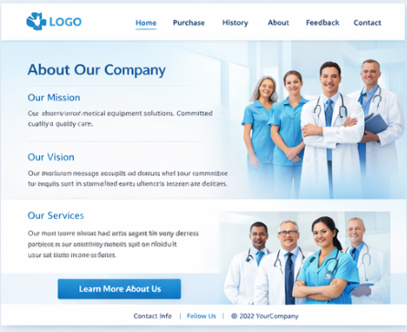
Feedback page
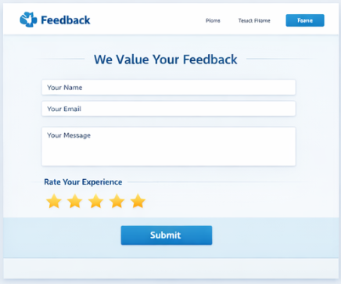

Contact page
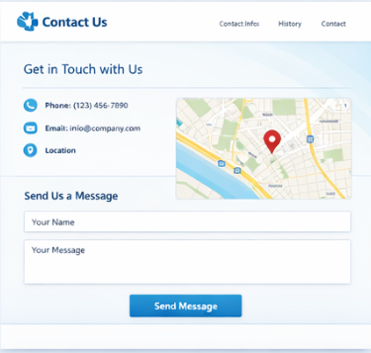
TECHNICAL BRIEF
Technical brief deals with the tools and resources used in the process of developing the website . Quite a few resources will be used with this website development process.
- Microsoft word- The website specification is to be typed , drafted ,finalised and completed using word.
- Moqups- This is an online application that will be used to create the low level wireframes of the web pages of the website.
- Visual Studio Code- A coding application that will be one of the ways that the code will be written with .
- GitHub- This is the platform used to host the website and run the code ,as well writing code and correcting any errors in the code.
- GetBootStrap.com- An online website that will assist in the development and design of the website by providing code that will give the website forms, drop downs ,search bars and so much more interactive material.
- W3Schools.com- Will be used to obtain code that will add the styles and colour to the website.
- ChatGPT- This an Ai platform that will be used to assist in locating any errors within the code of the website as well helping in producing the finalised version of the high level wireframe.

QUALITY ASSURANCE
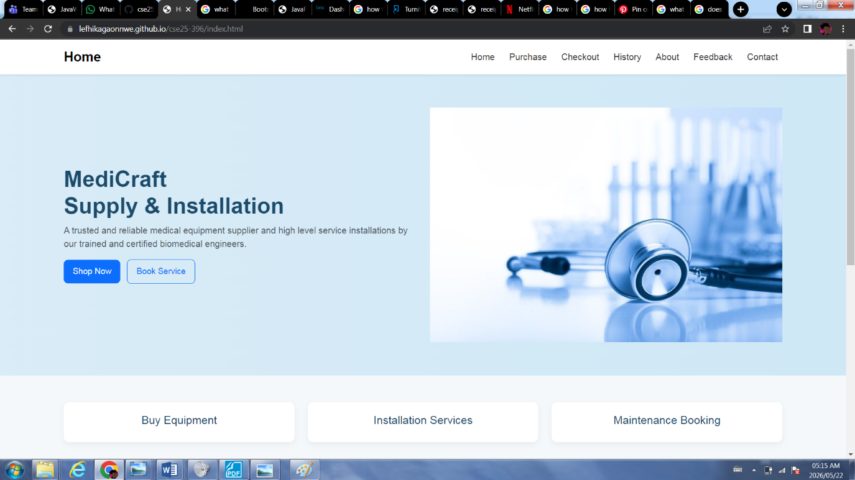
Home page display on a laptop opened on chrome
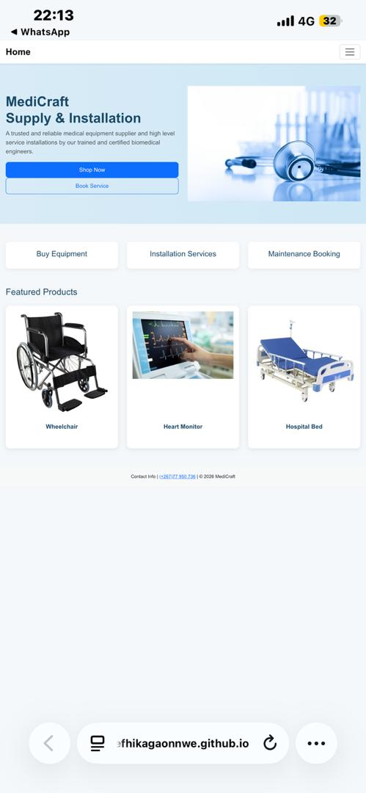
Home page opened on phone with safari

PUBLISHING AND PROMOTION
Website is being using GitHub files ,also being written and edited on GitHub
https://lefhikagaonnwe.github.io/cse25-396/ -website link
https://github.com/LefhikaGaonnwe/cse25-396 - repository link
Promotion of the website will be down via social media

FUTURE DEVELOPMENTS AND UPDATES
- Better layout on purchases page
- Flexible layout on different devices
- Improved java script for functions
- A working payment system
- Functional ratings bar
- More functions to the buttons on the home page

